HTTP PROTOCOL

CODE:

#post request

#curl -d "name=Ashish" -X POST http://10.1.66.136:8000/

#curl -X PUT http://localhost:8000/ -d "Ashish K"

import socket

import os

# Define socket host and port

SERVER_HOST = socket.gethostbyname(socket.gethostname())

SERVER_PORT = 8000

# Create socket

server_socket = socket.socket(socket.AF_INET, socket.SOCK_STREAM)

#server_socket.setsockopt(socket.SOL_SOCKET, socket.SO_REUSEADDR, 1)

server_socket.bind(('localhost', SERVER_PORT))

server_socket.listen(1)

print('Listening on port %s ...' % SERVER_PORT)

while True:

# Wait for client connections

client_connection, client_address = server_socket.accept()

#print("Accepted")

# Get the client request

request = client_connection.recv(4000).decode()

print(request)

headers = request.split('\n')

if "GET /" in headers[0]:

# Get the content of the file

filename = headers[0].split()[1]

if filename == '/':

filename = 'index.html'

try:

fin = open('E:/Sem-5/CN Lab/HTTP Protocol/httpfile/'+filename)

content = fin.read()

fin.close()

# Send HTTP response

response = 'HTTP/1.0 200 OK\n\n'+ content

except FileNotFoundError :

fin = open('error.html')

content = fin.read()

fin.close()

response = 'HTTP/1.0 200 OK\n\n'+ content

elif "POST /" in headers[0]:

response = 'HTTP/1.0 200 OK\n\n'+headers[-1]

elif "PUT /" in headers[0]:

file1 = open("db.txt", "a")

file1.write(headers[-1]+"\n")

file1.close()

response = 'HTTP/1.0 200 OK\n\nData is written using PUT request.'

elif "DELETE /" in headers[0]:

filename=headers[0].split('/')

filename=filename[1]

filename=filename.split(' ')[0]

print(filename)

try:

os.remove(filename)

response='HTTP/1.1 200 OK\n\nFile Deleted Successfully'

except:

response='HTTP/1.1 204 No Content\nFile Does not exist'

client_connection.sendall(response.encode())

client_connection.close()

# Close socket

server_socket.close()

GET REQUEST (index.html):

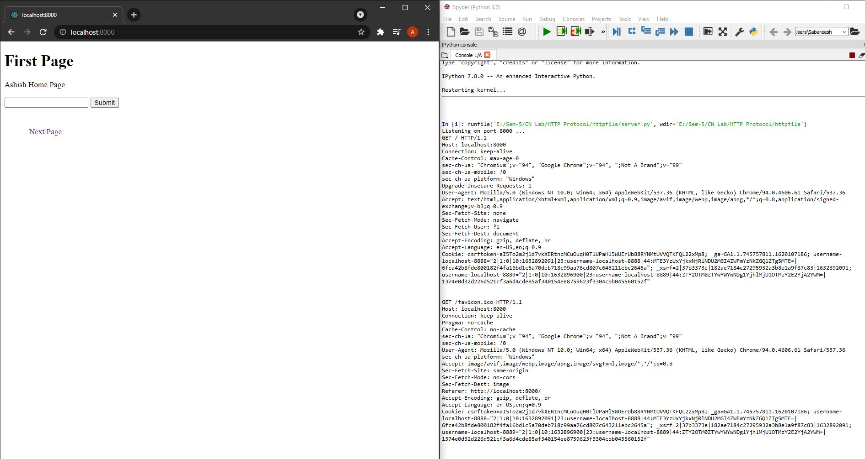

GET 404 FILE NOT FOUND:

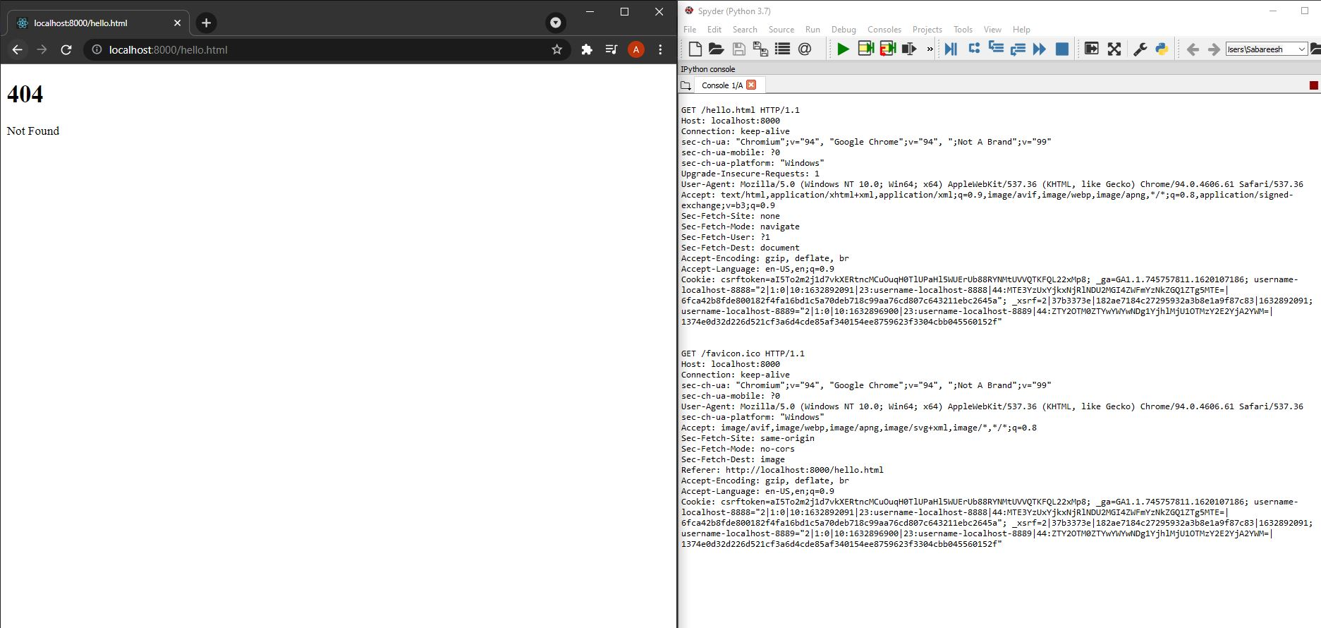

ANCHOR TAG:



GET SECOND PAGE(using anchor tag):

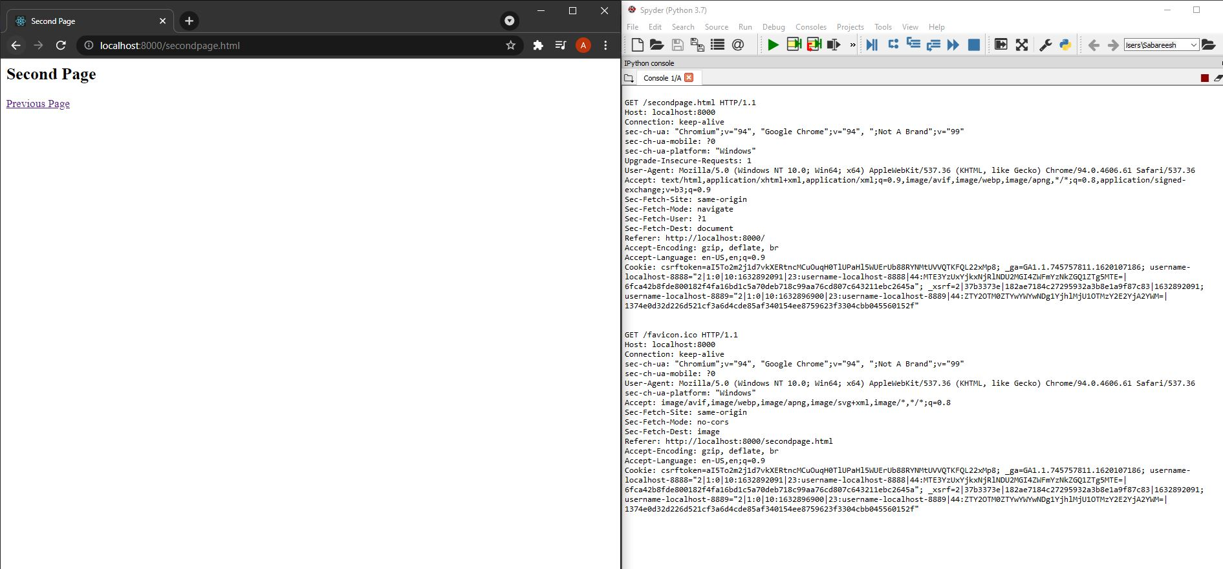

POST REQUEST:

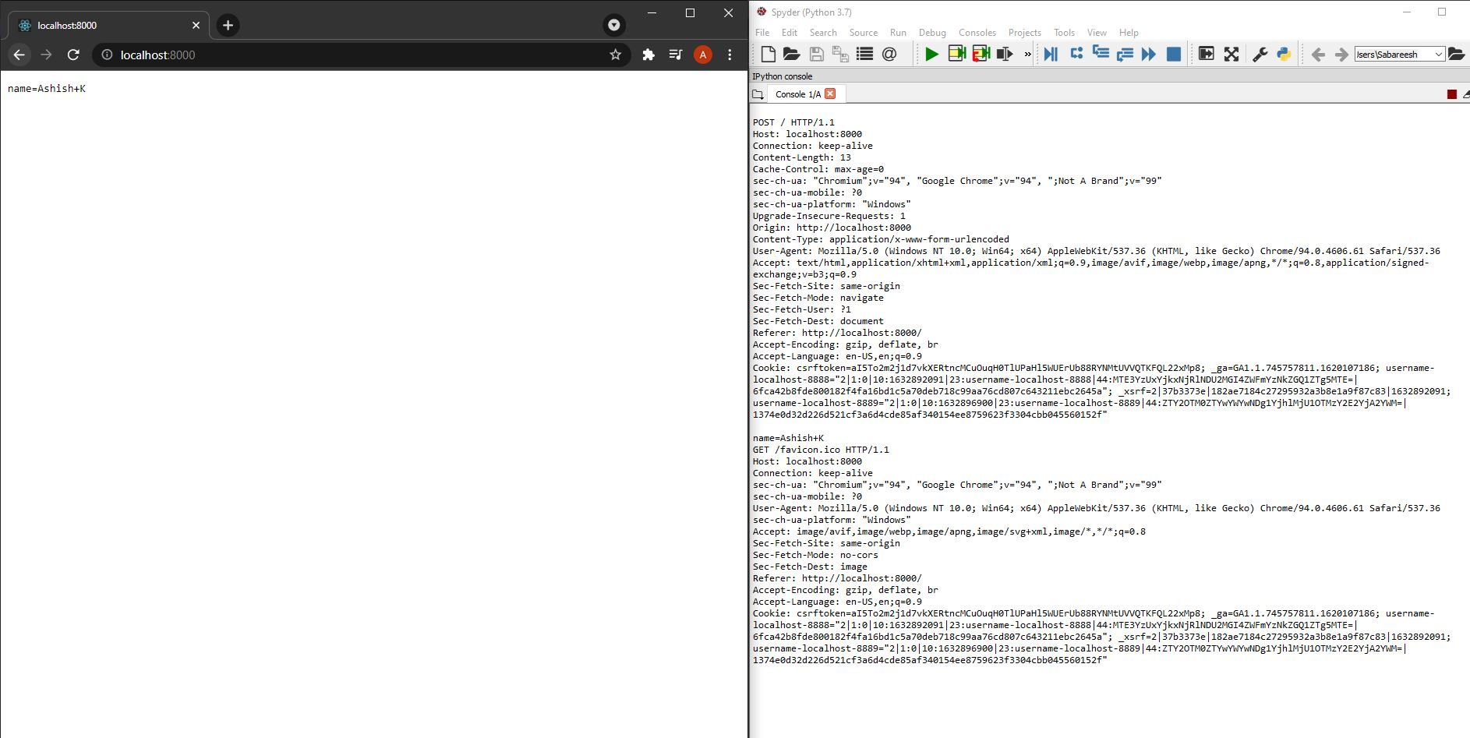

PUT REQUEST:

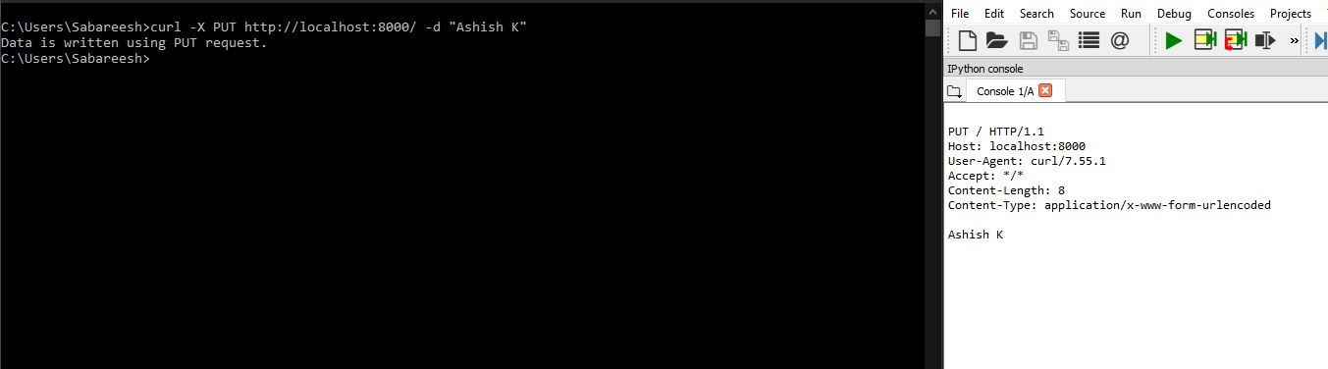

PUT DATA IN FILE:



DELETE REQUEST:

